**Experimental Analysis of Spark Ignition Performance**

Christopher R. White

MWG: David Bedding, Jorge Godoy, Samuel Hordeski, Kevin Myers, Justin Sandler

Department of Mechanical Engineering

Lafayette College

Easton, PA 18042

**Abstract**

The majority of automobiles operate on the four-stroke internal composition (IC) engines, which transfer chemical energy via a spark ignition (SI) process into mechanical work to drive a piston. Since IC engines produce useful torque over a limited range of crankshaft rotational speeds, automobile engine manufacturers increase engine performance by designing engines that flatten the torque-versus-rotational speed curve in order to have high torque at both high and low speeds without sacrificing power output. The purpose of this experiment was to determine the optimal shaft rotation speed ranges to achieve the maximum engine efficiency for a Briggs & Stratton V-Twin OHV 16 engine by applying simulated parasitic loads via a D-100 Small Engine Dynamometer. Crank shaft angle, torque, shaft speed, and engine cylinder internal pressure were measured for single cycles while applying power loads between ___ and ___ hp via fluid loads for the cases of low, middle, and full throttles. This range of loadings was used to explore the effect of parasitic loadings between low and high end torque on the actual engine. The experimental performance of the engine was evaluated based on the torque and powercurves. The results were compared to published data from manufacturer [3]. **The low throttle case accieved a _______ of _______ 59.9±2.6% with a cycle thermal efficiency of 1.14±0.57% and condenser effectiveness of 0.17±0.02. The middle throddle had the ______ efficiency with a the ________ of 1.14±0.57. The full throttle case achieced a the ______ efficiency with a the ________ of 1.14±0.57.**

**Introduction and Methods**

The U.S. Energy Information Administration predicits that the nominal price of petroleum will be $2.73 per gallon by 2016 as a result of the increasing linear trend present since 1998, when petroleum was $1.03 per gallon[1]. The automotive industry is severely impacted by the increase in fuel price coupled with the uncertainty of the Earth’s fossil fuel reserves. According to the law of conservation of energy, designing an engine of higher efficiency results in both environmental and economic incentives, since more energy is extracted from the fuel. This can be accomplished by maximizing the torque while holding it constant over the low and high end speeds. In order to test and analyze a prototype IC engine, the Otto cycle is used to represent the actual four-stroke cycle as an idealized thermodynamic cycle with no internal irreversibilities and is illustrated in Figure 1a. Since the Otto cycle is executed in a closed system, it can be analyzed using the energy balance equation, expressed as

${(q}_{in}-q_{out})+{(w}_{in}-w_{out})= ∆u$ (Btu/lb) ⑴

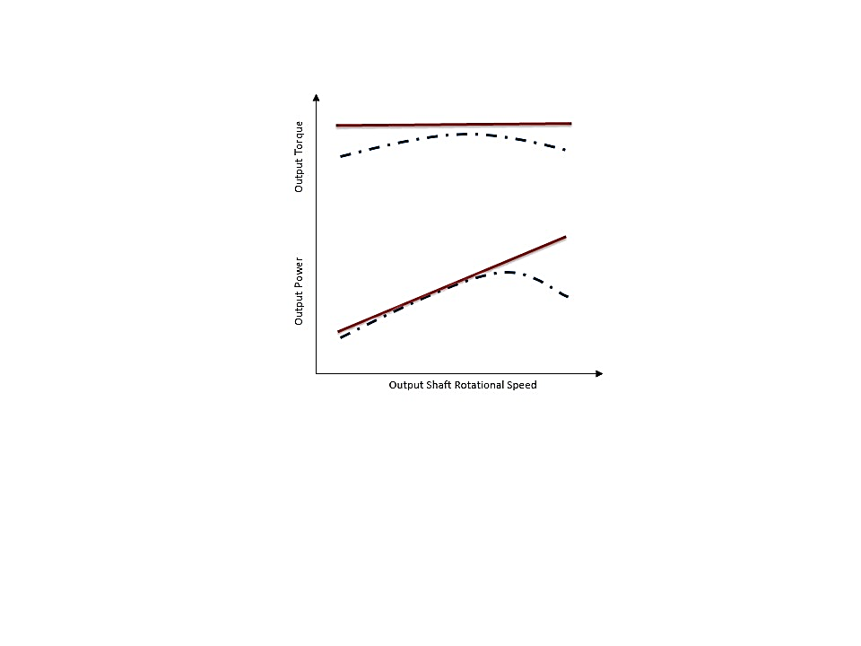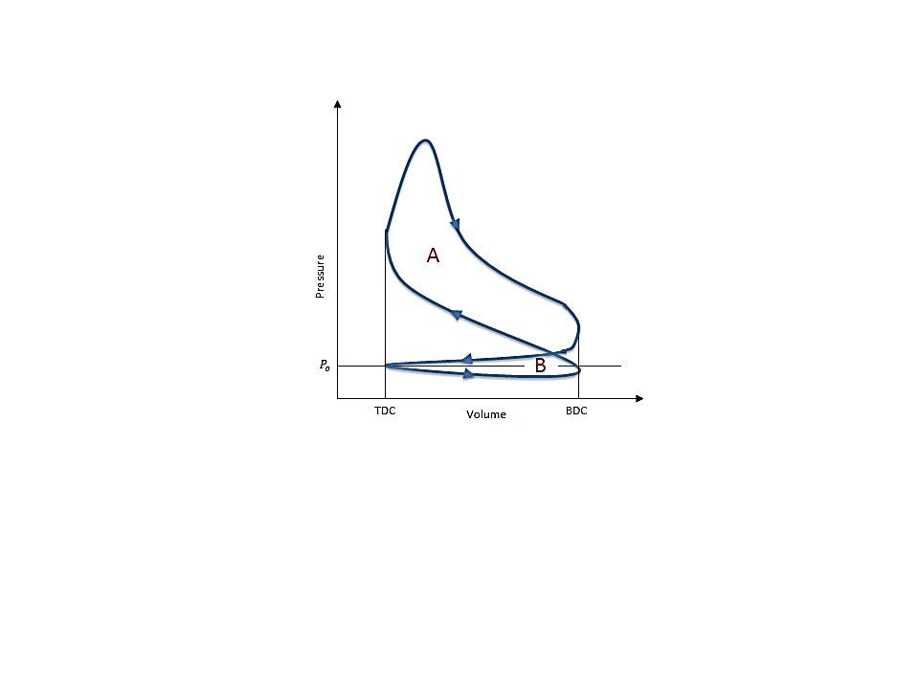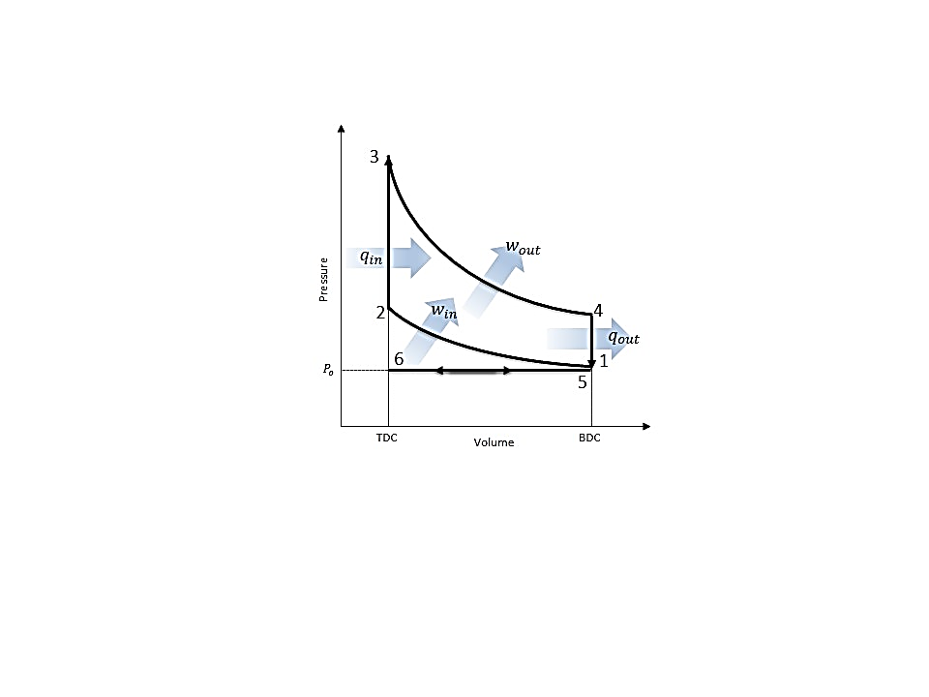where $q$ is heat transfer, $w$ is the work, and $u$ is the internal energy. The engine can be analyzed with this expression under the assumption that air behaves as an ideal gas with negligible changes in kinetic and potential energy.

**Figure 1: (a) P-V Diagrams for the Otto Cycle [5] and (b) Actual Four-Stroke Engine Cycle [5] (c) Ideal (solid) vs Actual (dash) Torque and Power [6] Replicated by White C.**

The Otto cycle consists of 6 processes, resulting in the crankshaft rotating a total of 720˚ per cycle. It begins with process 6-1 as a fuel-air mixture is drawn into the engine cylinder isobarically as the piston travels from top dead center (TDC) to bottom dead center (BDC), resulting in an increase in the cylinder volume. The mixture is then isenropically compressed in process 1-2 as the piston travels from BDC to TDC resulting in an increase in the pressure. Heat is transferred isochorically to the mixture in process 2-3 via ignition from spark plug found in SI engines.The fuel-air mixture expands in the cylinder performing work on the piston isentropically during the power stroke in process 3-4, driving the piston from TDC to BDC. Heat is rejected isochorically from the engine in process 4-5 at BDC. The mass of spent fuel is expelled from the engine to the environment in process 5-6 through the exhaust stroke and the entire cycle repeats. Using Eq. (1) with the appropriate assumptions allows for the thermodynamic analysis of each of the processes of the Otto cycle in order to determine work and heat transfer. The volume between BDC and TDC represents the displacement volume of the piston. The volume between TDC and the top of the cylinder represents the clearance volume where the combustion of the compressed fuel-air mixture takes place.

The actual IC four-stroke engine P-V diagram has slight variations compared to the Otto cycle due to the behavior of the piston and the fuel-air mixture, resulting in a certain amount of work per cycle as illustrated in Figure 1b. The work of the piston is determined through the integral of the product between the pressure within the cylinder and the differential cylinder volume, expressed as

$W_{p}=\oint{PdV}$ (ft-lb) ⑵

where P and $V$ are the pressure and volume of the cylinder respectively. As illustrated in Figure 1b, the gross work is the positive work is denoted by area A produced by the power stroke due to the interaction between the expanding gas and the piston. The negative work is denoted by area B, which is due to the pump work of the piston required to draw the fuel-air mixture in and expel exhaust. The summation of the produced and consumed work of the four-stroke cycle is is the net work, which is the pump work subtracted by the gross work. However the net work of the engine is not exactly the same work that is truly outputted by the engine.

Brake work is the actual available work produced by the engine and is measured by the dynomomer and is determined by the product of the torque and the rotational speed of the output shaft. The brake work is less than the net work due to irreversabilities within the system in the form of heat transfer and friction which are not accoundetd for by the net work. Therefore the mechanical efficiency is used to evaluate the performance of the engine, expressed as

$η=\frac{W_{b}}{W_{net}}$ = $\frac{τ×RPM}{W_{net}}$ ⑶

where $W_{b}$ is brake work, $τ$ is torque, $RPM$ is the angular velocity of the output shaft, and $W_{net}$ is the net work determined using Eq.(2). The gross brake horsepower from Figure 1b is used for the brake horsepower since it is the measure of available power via the output shaft without parasitic loadings, whereas net brake horsepower includes the parasitic loads that rob the system of power.

In the actual four-stroke engine, the amount of fuel-air mixture entering the cylinders is controlled through by a butterfly valve loacated at the upstream end of the intake system by controlling the flow rate via constriction or obstruction during each cycle. The throttle is used to control the desired power or speed.

In the current study, the four-stroke IC engine efficiency was experimentally determined for low, middle, and full throttles while applying parasitic loadings. The actual cycle was compared to the idealized Otto cycle and published data[3] in order to validate the experimental process.

The experiments were performed on an instrmented Briggs & Stratton V-Twin OHV 16 engine with a **D-100 Small Engine Dynamometer attached to the engine output shaft**. Crank shaft angle, torque, shaft speed, and pressure were measured for 3 complete cycles for various fluid loadings between minimum and maximum water flow rate via the dynamometer at low, middle, and full constant throttle settings. The experimental schematic and locations of the instrumentation are illustrated in Figure 2.

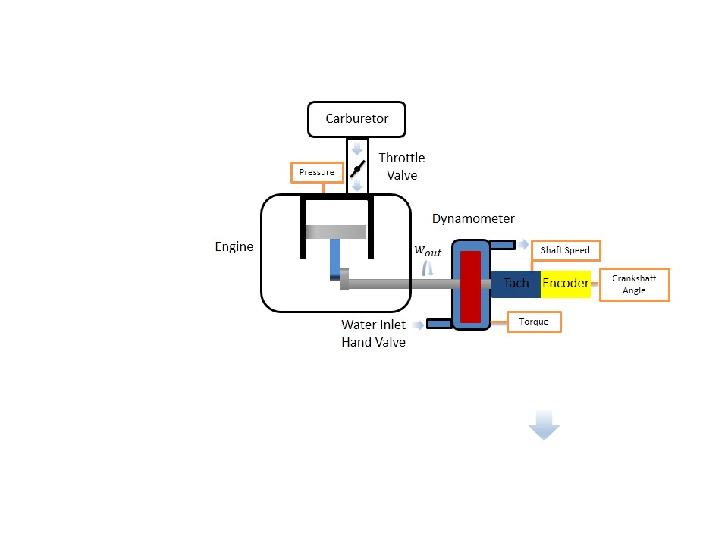**Results and Discussion**

**Figure 2: Experimental Four-Stroke Engine Schematic with Instrumentation Locations: AutoPSI Pressure Sensor, D-100 Small Engine Dynamometer Strain Gauge for Torque, Tachometer for Shaft Rotational Speed and Encoder for Crankshaft Angle [White C.]**

The following experiments were considered: (1) varying fluid load at low throttle, (2) varying fluid load at middle throttle, and (3) varying fluid load at full throttle.

The operation of the Briggs & Stratton V-Twin OHV 16 was initiated according to startup procedure in the Operating Instructions at a laboratory temperature of 75.2˚F and barometric pressure of 14.7 psi [3]. For each throttle case, the butterfly valve was adjusted to the corresponding throttle position, where it remained for the duration of the loadings. The range of loadings was controlled via water flow rate, adjusted gradually from the minimum flow rate of 10 GPM applied to the output shaft using the D-100 Small Engine Dynamometer in order to observe the variation in engine mechanical efficiency between low to high output shaft speed. Crankshaft angle, torque, shaft speed, and pressure were recorded for each of the approximately 50 loadings for each throttle case. At the locations illustrated in Figure 2, crankshaft angle, torque, and pressure were measured for each load case. **The work and heat transfer were determined using Eqs. (2-5) and** P-V diagrams for each throttle case were generated actual four-stroke cycles in Figure 3. Volume determined by geometric relationship [3]. The engine efficiencies for the low, middle, or high throttle were **determine for each case using Eq.(3) and displayed in Figure 4**. Due to the lack of information regauring senor sensitivity, error in torque and power was sencor calibration so evaluated variation based on variation in rpm and torque measurements using stdev and students t at 95% conf.. work and power was evaluated at a singly cycle for each load case and displayed in figures ___ and ____.

Based on the P-V curves for the actual four-stroke cycle for each throttle case are displayed in Figure 3. Since the cycles are plotted for each throttle case at the middle loading, they should be approximately at the same load. As displayed by the diagram as the throttle increases, the pressure within the enginue during combustion increases, resulting in a much greater power stroke process. The exhaust/intake region of the pump work remains consistent across throddling cases. This is due to the fact that the exhaust/intake processes occurring isobarically at at the same BDC and TDC volumes, therefore there are no differences between throddling and the pump work region. The compression stroke is for the low throttle has a lower stroke compared to the higher thottles due to the crankshaft storing more rotational kinetic energy at a higher rotational speed, therefore the compression stroke occurring at a greater slope.

**Figure 3: Low, Middle, and Full Throttle P-V Diagram for Actual Four-Stroke IC Engine at Middle Loading Case for Each Throttle**

Figure 4a displays the experimental mechanical efficiency vs rotational speed of the output shaft. It displays trend that shows that mechanical increases with higher loadings. At no loading the egine is mechanical efficiency is zero since no usable work is being outputted from the engine.The speed of the output shaft decreases because of the increased loading since the resistance within the dynamometer is large and therefore the engine must expend more energy to transfer into the output shaft in order to make it spin. Through propagation error, the error was determined for the mechanical efficiency and was determined to be below 0.13, indicating that the error was insignificant in affecting the results.

**b)**

**a)**

Figure 4b displays the experimental torque vs rotational speed of the output shaft. The low throttle case is similar to the end trend found in the middle and full throttle cases. Therefore the low throttle behaves similary and means that no useful torque is being produced at low throttles hich means the working fluidn is not porivind enough power to the piston producing power. However they have regions at lower throttles where the throttle follows a linear horizontal region similar to that shown in Figure 1c for the desired torque curve. in order to achieve high constant torque throughout the low and high rpms. Through propagation error, the error was determined for the mechanical efficiency and was determined to be below 0.3529, indicating that the error was insignificant in affecting the results.

Figure 4c displays the experimental power vs rotational speed of the output shaft. Since no useful torque is being produced at low throttles hich means the working fluidn is not porivind enough power to the piston producing power. This is also true at high range speeds for the middle and high cases. However they have regions at lower throttles where the power follows a positive slop elinear region similar to that shown in Figure 1c for the desired power curve. The error was determined for the mechanical efficiency and was determined to be below 0.2152, indicating that the error was insignificant in affecting the results. Power also decreased due to the misfiring occurring withion the engine at high speeds, this is evident in the P-V diagram variation for 3 cycles at each loading case. Due to theism is fring, the fuel-air mixture is not always combusting at the optimal point. The spark ignition firing rate is not optimal for every speed. Power is realted to the torque and the rotational speed of the shaft therefore the shaft functions as an energy storage device for kinetic energy. Because kinietic energy involves a squared velocity term, the power vs speed graph results in a parabolic shape.

**d)**

**c)**

Figure 4d displays the experimental power vs rotational speed of the shaft compared to the published data by Briggs & Stratton[3]. The cosample deviation was determined between each load case and the published data. The published data lies within the bounds of the error bars between the tested ranges of 1250 to 3250 RPM. However the published data is similar to the idealized curve in Figure 1c. Visually the pumblished data does not display a significant decrease in power at high rotational speeds. Based on the published data, it would most likely due to the fact that the Briggs & Stratton adjusted the ****firing rate for each loading so that the engine data would display a linear trend in power. However in the actuallaity the enine would not be running at these optimized firing rates.

**Figure 4: Low, Middle, and Full Throttle (a) Mechanical Effeciency, (b) Torque, (c) Power, (d) and Power with Briggs & Stratton Curve Fit Error vs Speed for Each Throttle Case for Actual Four-Stroke IC Engine**

Figure 5a diplays the experimental gross power vs the rotational speed of the output shaft. At high RPMS approximately 3500 RPM for full throttle and 2750 RPM for middle throttle the gross power increases rapidly until it peaks. After which the peak it decreases slowely. The low throttle case is an example of data is in a region of velry low torque and rpm wich makes it does not led itself to be applicable for the trend of applicable rotational speed since it was sampled below the threshold of 1700 RPM.

****Figure 5b diplays the experimental gross power vs the rotational speed of the output shaft. According to the diagram, the pump work increases as the roational speed increases, due to the increase in intake and exhast mass flow rate of the fuel-air mixture.The increased maximum pressure is dues to the combustion processes, as more fuel is injected at the same consistand BDC volume. Increaseing the ammount of work produced since there is a greater pressure which results from Eq.(2). The change in the intake/exhaustegiion of the P-V diamgram is due to when the throttle is wide open, the engine intake is approximately at ambient atmospheric pressure. When the throttle is partially closed, a manifold vacuum develops due to the intake dropping below ambient pressure.

**Figure 4: Low, Middle, and Full Throttle (a) Gross Power and (b) Pump Power vs Speed for Each Throttle Case for Actual Four-Stroke IC Engine**

**Conclusions**

The purpose of this experiment was characterize the performance of the Briggs & Stratton V-Twin OHV 16 engine by determining the effect of variable loadings on the cycle. The engine was rated for 16 hp, which the experimental power results fell in this range.

**Though the conservation of energy and the generator efficiency correlation, the turbine efficiency, cycle efficiency, and condenser effectiveness were determined. The uncertainties for the turbine efficiency were below 4%, significantly high for the thermal efficiency around 0.6% and below 0.0205 for the condenser effectiveness. While cycle efficiency was low with a high uncertainty, this is attributed to the prediction of the boiler heat transfer. Based on the experiments it was determined that the 60 bulb load was the optimal loading, since it achieved a thermal turbine efficiency of 59.9±2.6%. This was the loading at which the efficiency curve began to plateau, whereas for the 100 bulb loading, the turbine efficiency began to decrease. Therefore the steam turbine operates at maximum efficiency at a loading of 60 bulbs.**

**References**

1. U.S. Energy Information Administration - EIA - Independent Statistics and Analysis. (n.d.). Retrieved March 26, 2015, from http://www.eia.gov/forecasts/steo/realprices/
2. Ҫengel, T.A. and Boles, M.A. (2002) *Thermodynamics: An Engineering Approach,* McGraw Hill, 4th Edition.
3. Rossmann, T., Sabatino, D. & Utter B. (2015). *ME 475: Spark Ignition Laboratory Description*. Easton, PA: Lafayette College.
4. Moran, M. & Shapiro, H. (2004) Fundamentals of Engineering Thermodynamics, Wiley, 5th Edition.
5. Pulkrabek, W.W. (1997) Engineering Fundamentals of the Internal Combustion Engine, Prentice-Hall.
6. (n.d.). Retrieved March 27, 2015, from http://www.personal.utulsa.edu/~kenneth-weston/chapter6.pdf

489 – standard air assumptions

491 – otto cyfcle

95 - PDF part throttle

<http://gopowersystems.com/index.php?option=com_content&task=view&id=51&Itemid=60>

In the actual four-stroke spark-ignition engine, **Process 6-1** ..During this motion, a mixture of fuel and air is injected into the cylinder through the intake port.

During compression, both the intake and exuast valves are sealed andadiabatic compressussion.

… isochoric processs followd by adiabatic expansion. states 2-3 constant volume heat transfer to working gas from external source while piston is top dead center. states 3-4 is an adiabatic expansion (power stroke)

isochoric and isobaric compression. and.states 4-1 constant volume while heat is rejected from air. and processes 1-0 is the exhaust of the air to the atmosphere at constant pressure.

https://kb.osu.edu/dspace/bitstream/handle/1811/24538/Meyer_Jason_Honors_Undergraduate_Thesis.pdf;jsessionid=AC650AE2D8972C58C817F03F4D337109?sequence=1

there are mechanical losses in the throttling which reduces the engines efficiency

In the experimental set up, there are irreversabilities within the engine and which results in efficiencies for the engine. The brake work is the useful work is

Therefore they must designing an IC engine depends on the compromise between performance, fuel economy, and emissions.

Full throttle is when the throttle valve is fully open for when maximum power/ and or speed is desired